1 BASIC MATHEMATICAL OPERATION

#include<iostream>

using namespace std;

int main(){

int a,b;

a=5;

b=2;

cout << a+b <<"\n";

cout << a-b <<"\n";

cout << a\*b <<"\n";

cout << a%b <<"\n";

}

OUTPUT:

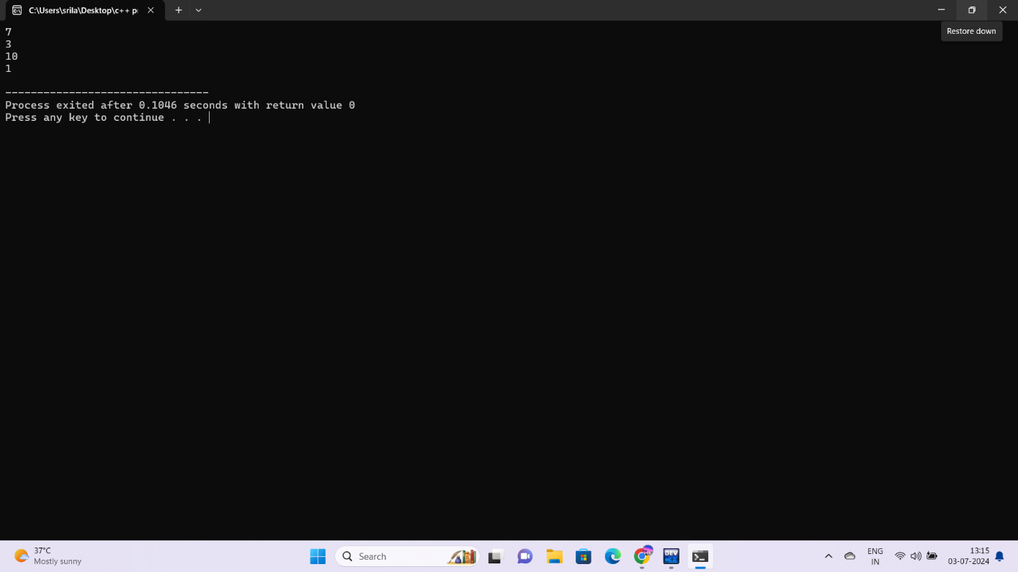

2.ODD OR EVEN

#include<iostream>

using namespace std;

int main(){

int x;

cout << "enter the number \n";

cin >> x;

if(x%2!=0){

cout << x << " is a odd number";

}

else{

cout << x << " is a even number";

}

}

OUTPUT:

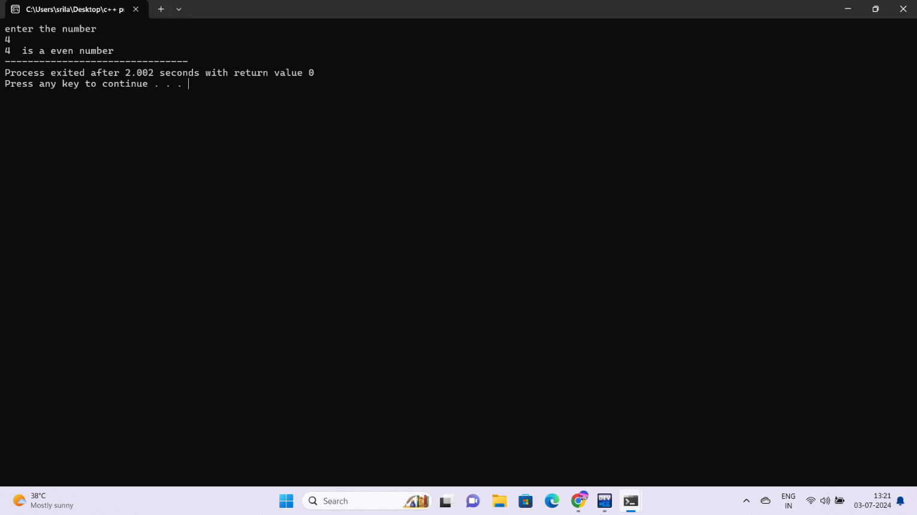

3.AVERAGE OF THREE NUMBERS

#include<iostream>

using namespace std;

int main(){

int a,b,c,sum;

cout<<"enter the numbers \n";

cin>> a;

cin>> b;

cin>> c;

sum=a+b+c;

cout<< "avg of three numbers " << sum/3;

}

OUTPUT:

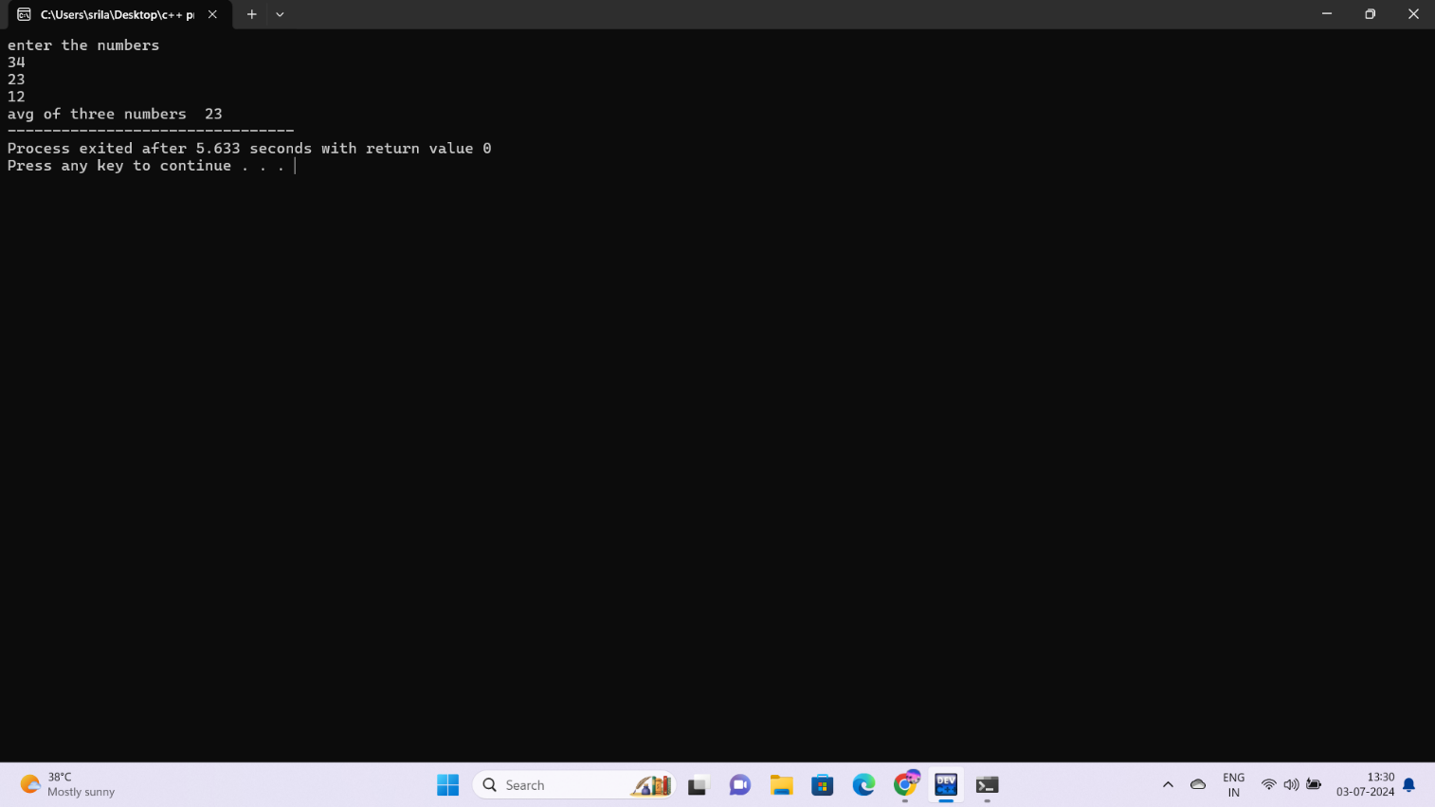

4.GIVEN NUMBERS OR EQUAL OR NOT

#include<iostream>

using namespace std;

int main(){

int a,b;

cout <<"enter the numbers \n";

cin >> a;

cin >> b;

if(a==b){

cout<< "they are equal";

}

else{

cout<< "they are not equal";

}

}

OUTPUT:

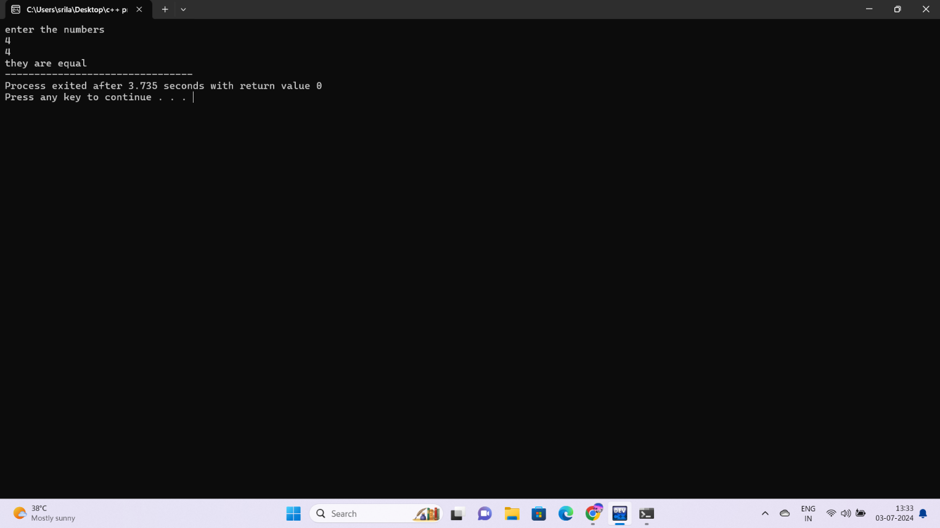

5.FLOATING NUMBER OPERATIONS

#include<iostream>

using namespace std;

int main(){

float a,b;

int x=a,y=b;

cout<< "enter the numbers\n";

cin>> a;

cin>>b;

cout<< a+b <<"\n";

cout<< a-b <<"\n";

cout<< a\*b <<"\n";

cout<< a/b <<"\n";

}

OUTPUT:

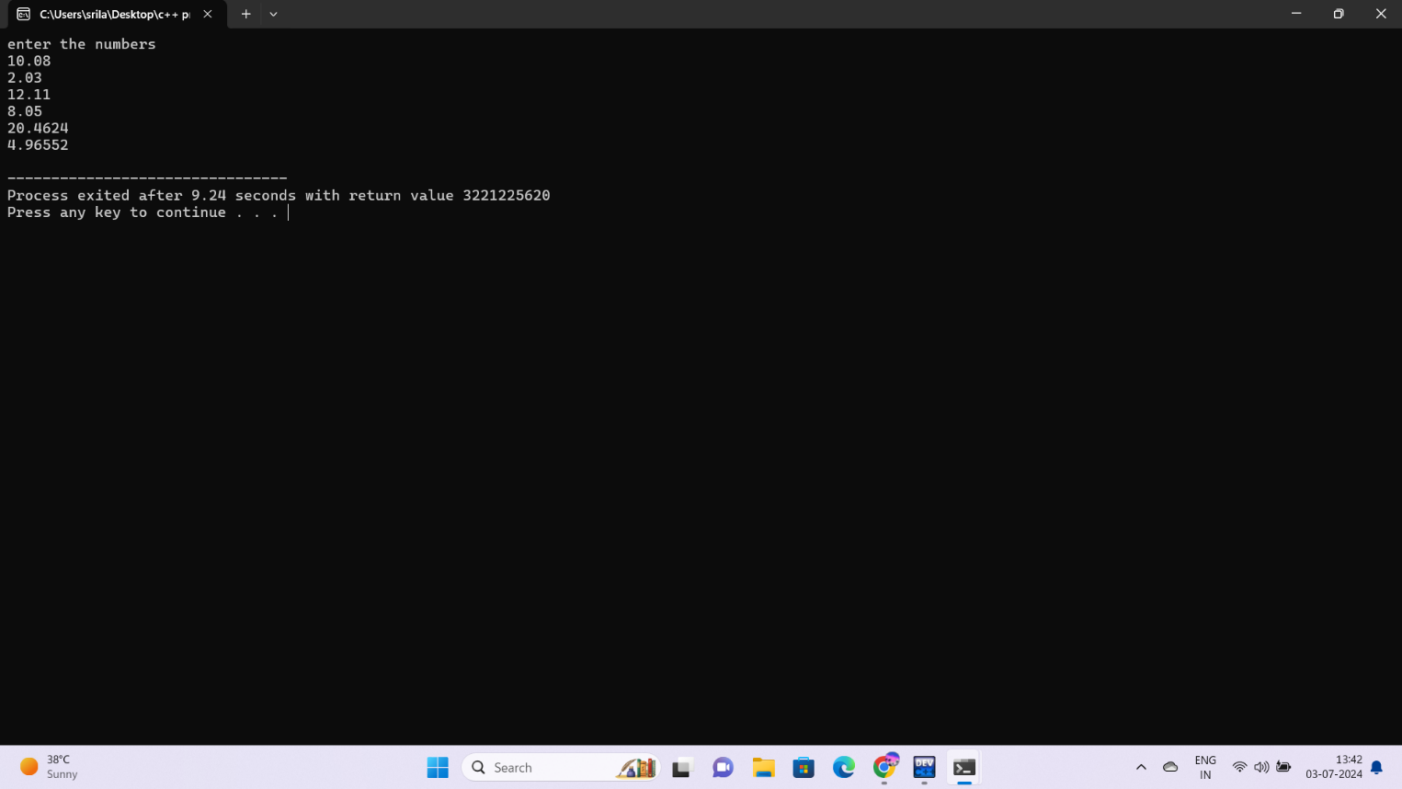

6.GIVEN NUMBER IS POSITIVE OR NEGATIVE

#include<iostream>

using namespace std;

int main(){

int x;

cout<<"enter the number \n";

cin>>x;

if(x==0){

cout<<" zero";

}

if(x<0){

cout << " it is negative number ";

}

else{

cout << " it is a positive number";

}

}

OUTPUT:

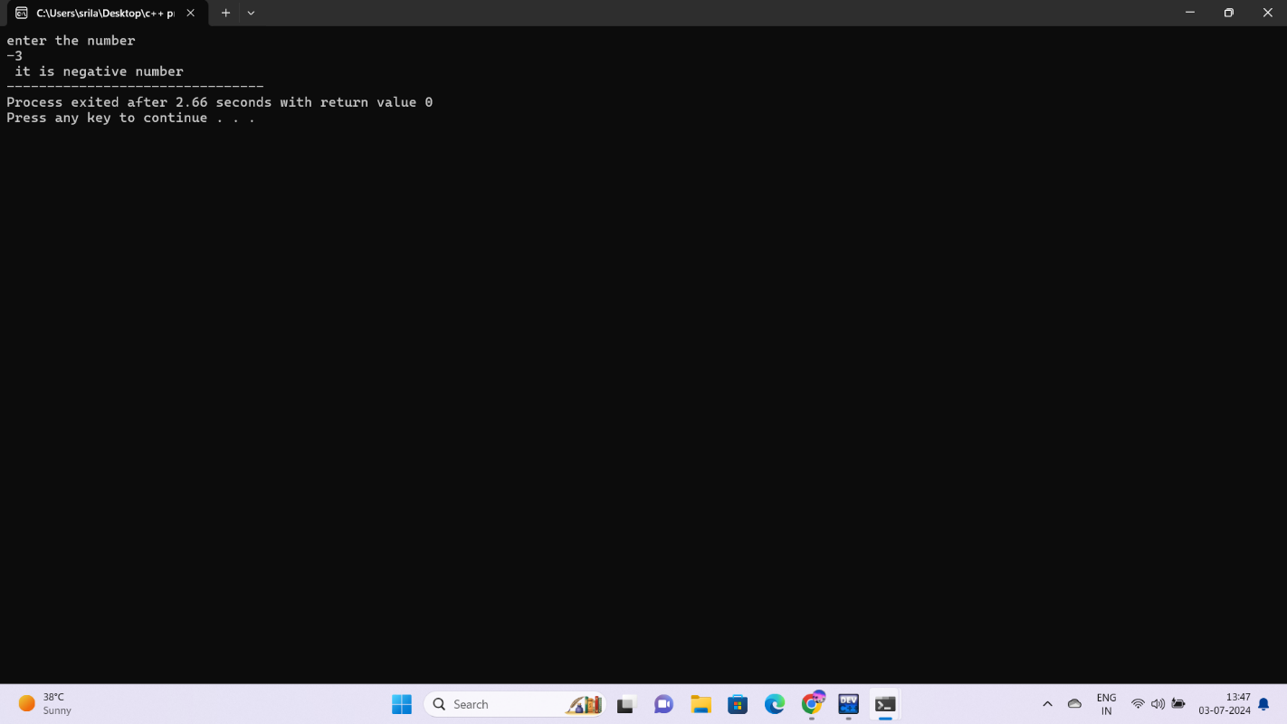

7. FIND GREATER NUMBER AMONG TWO NUMBERS

#include<iostream>

using namespace std;

int main(){

int a,b;

cout<<"enter the numbers \n";

cin>> a;

cin>>b;

if(a>b){

cout << a <<" is greater number";

}

else{

cout << b <<" is greater number";

}

}

OUTPUT:

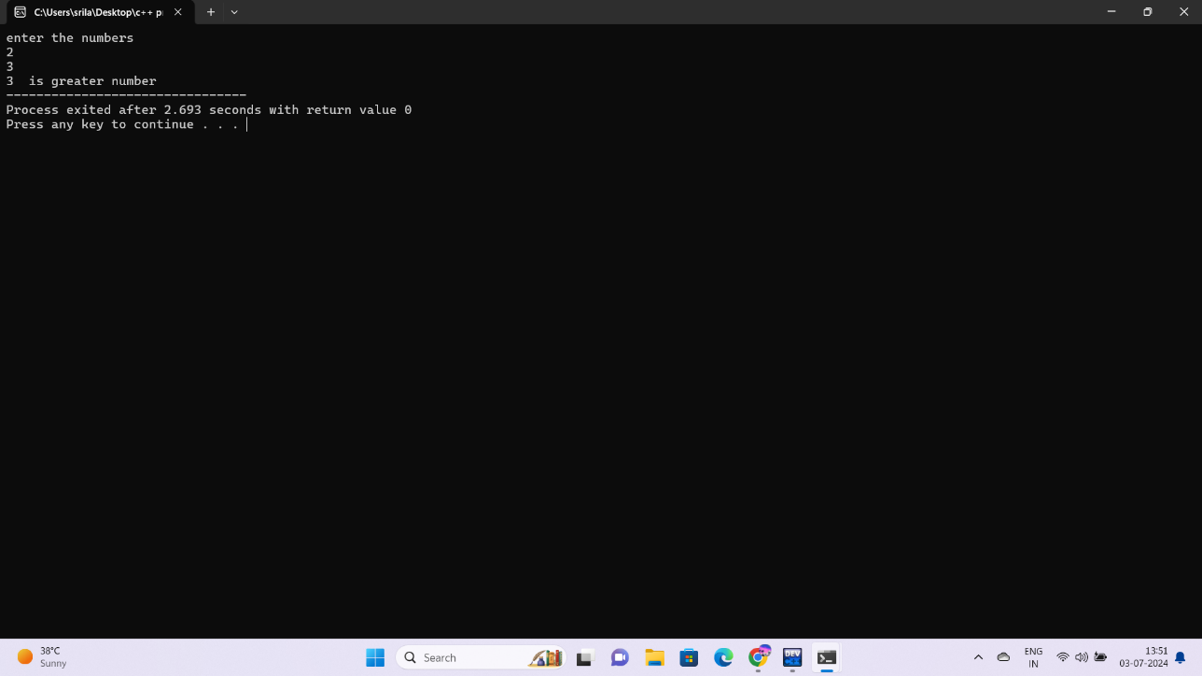

8.READ A FLOATING NUMBER AND ROUND IT USING CEIL AND FLOOR

#include<iostream>

#include<cmath>

using namespace std;

int main(){

double x;

cin>>x;

cout<< ceil( x);

}

OUTPUT:

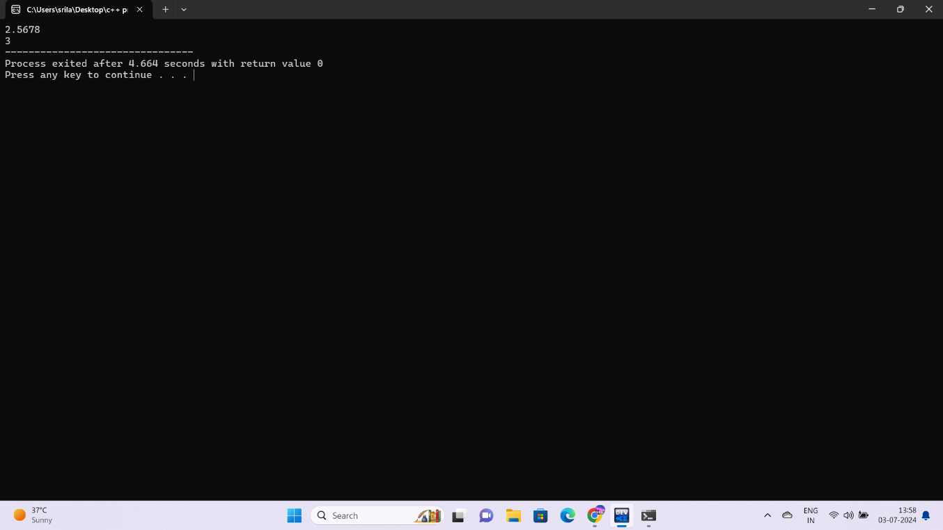

9.SWAPING OF TWO NUMBERS USING XOR OPERATIONS

#include<iostream>

using namespace std;

int main(){

int x,y;

x=23;

y=34;

cout<<"x = "<< x <<"\n "<<"y = "<< y<<"\n";

x=x^y;

y=x^y;

x=x^y;

cout<<"x = "<< x <<"\n "<<"y = "<< y<<"\n ";

}

OUTPUT:

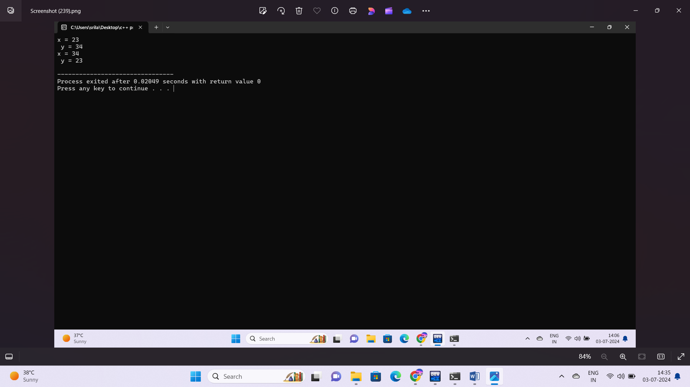

10.IDENTIFY GIVEN CHARACTER IS VOWEL OR CONSONANT

#include<iostream>

using namespace std;

int main(){

char a1,a,e,i,o,u;

cin>>a1;

if(a1==a||a1==e||a1==i||a1==o||a1==u){

cout<< a1 << "is a vowel";

}

else{

cout<<a1 << "is a consonant";

}

}

OUTPUT:

